Docker Image Creation Steps

Contents

Dockerize Spring Boot Microservice 1

Dockerize Angular Application 6

# Dockerize Spring Boot Microservice

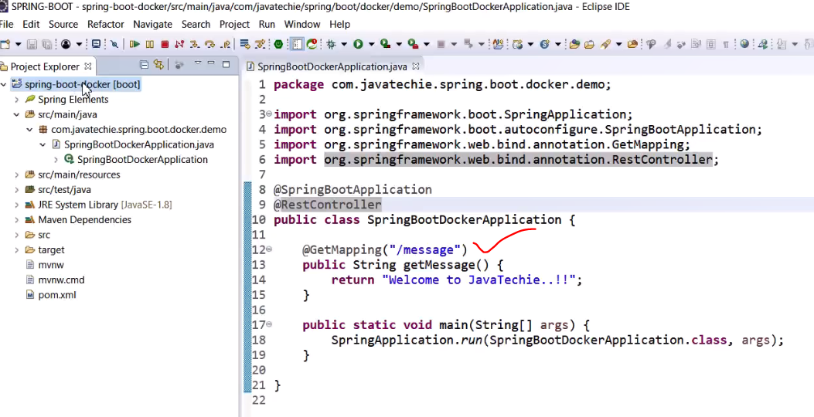

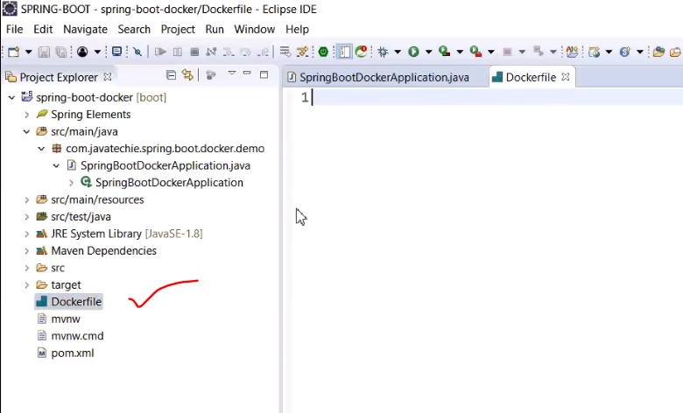

Create a new file “Dockerfile”, with D capital.

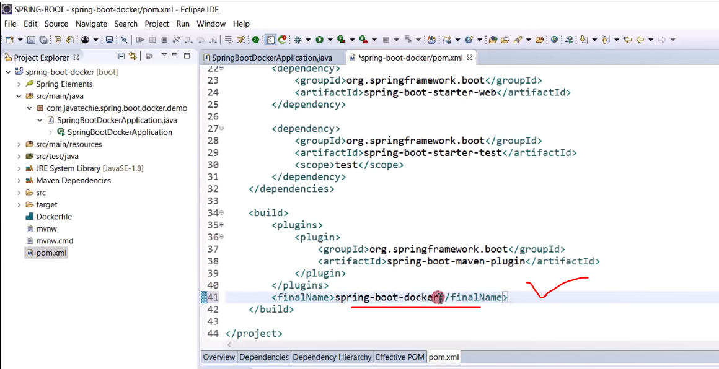

Specify the final jar name here.

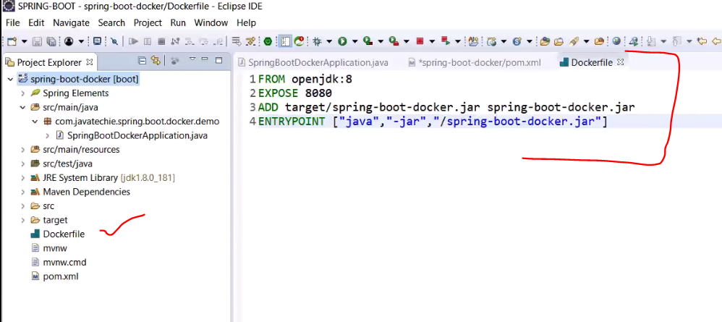

FROM – what is the project based on

EXPOSE – the local port to expose

ADD – add the jar from the target folder after the build

ENTRYPOINT – what command needs to run to start the application

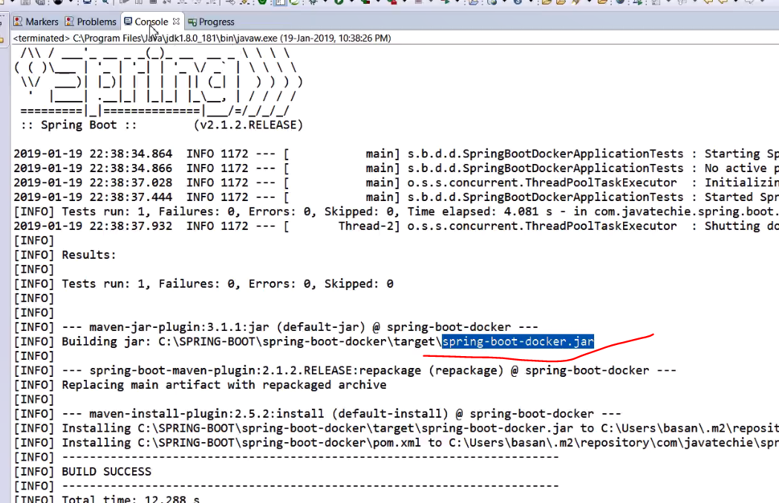

Build the jar.

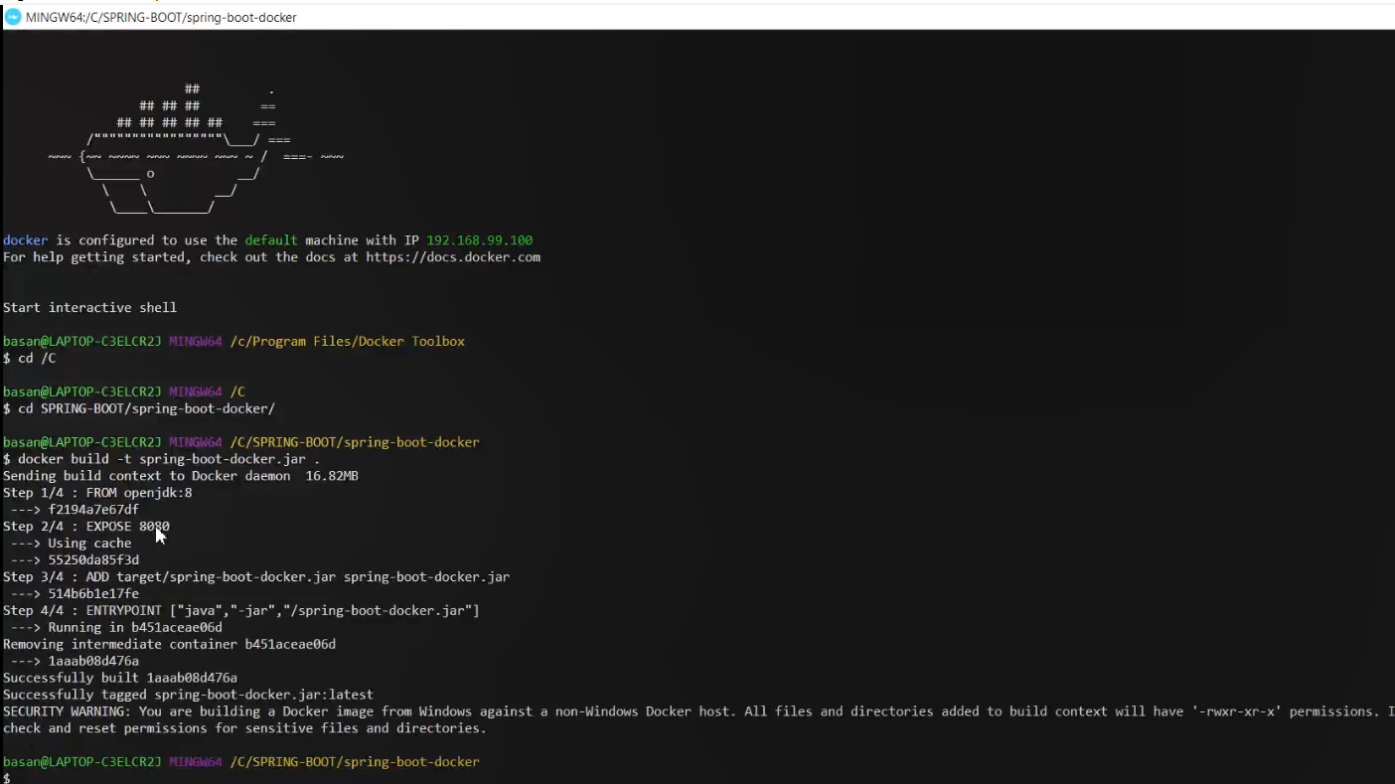

Command:

Docker build -t <project.jar> .

Here as you can observe it ran all the 4 steps one by one as mentioned in our Dockerfile.

Now check the image

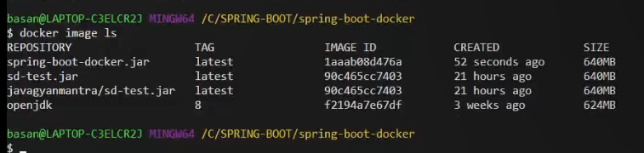

Command:

Docker image ls

Next, we will run the docker image.

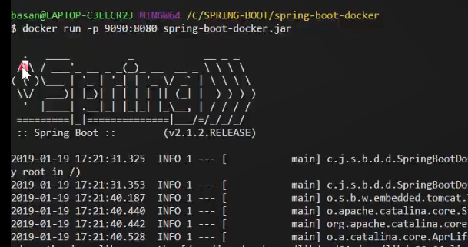

Command:

Docker run -p <container port>:<local port as mentioned in EXPOSE> <docker image>

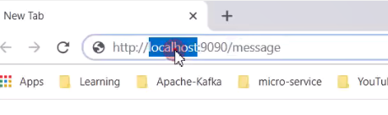

Instead of localhost, mention the IP address.

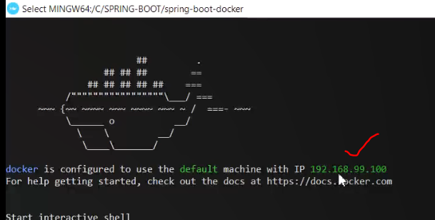

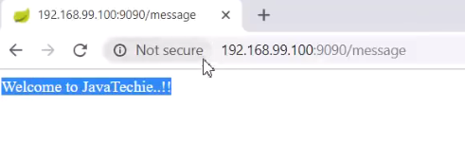

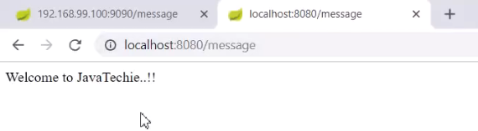

**Note:**

Here localhost will work.

Done!

# Dockerize Angular Application

It’s the same process for all applications, just the Dockerfile will be different.

Create the project.

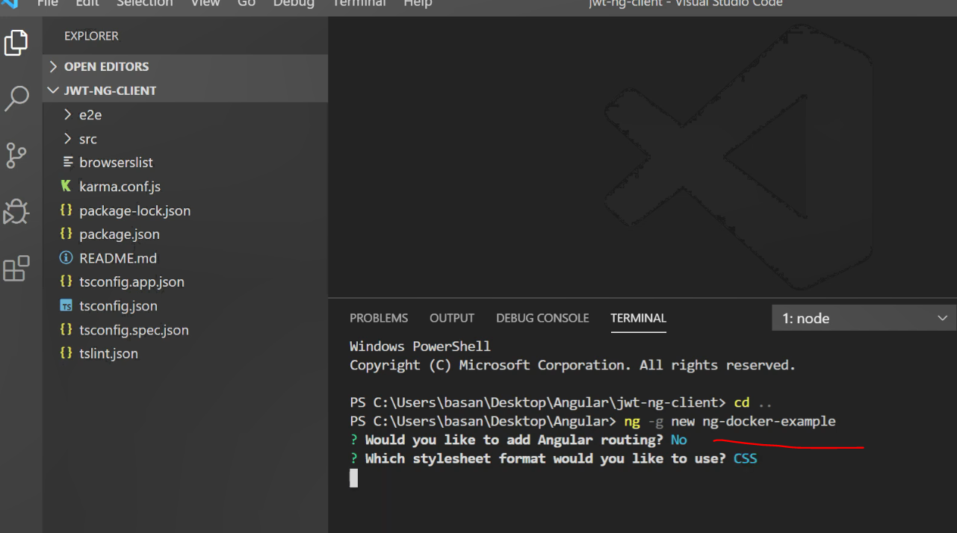

Build the project:

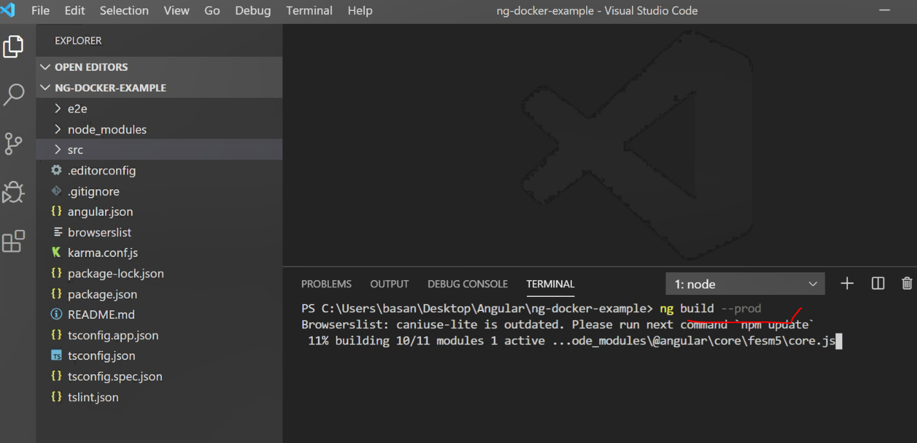

All the compiled files are here:

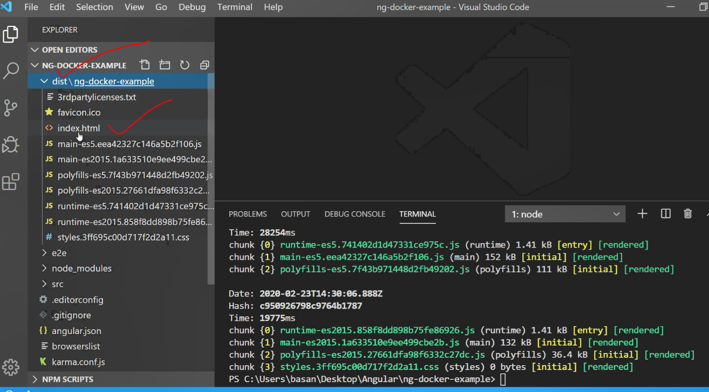

Create the Dockerfile in the root directory: Note: “D” should be capital.

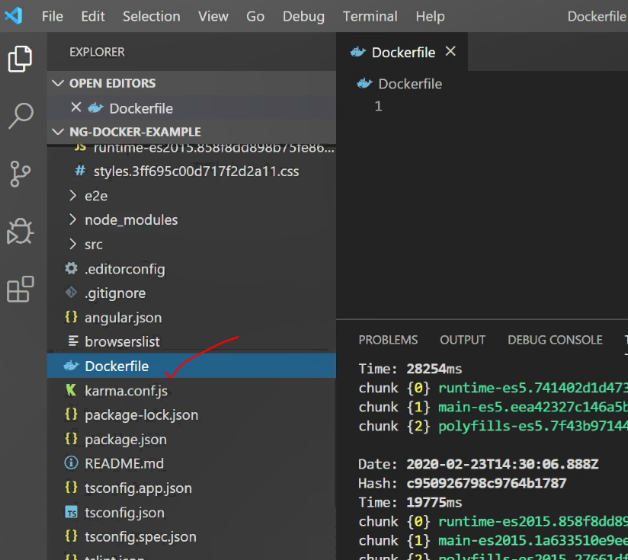

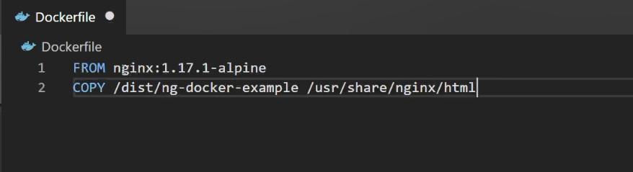

FROM – download nginx with this version

COPY – Then copy all the complied files from dist folder and copy it in the docker container

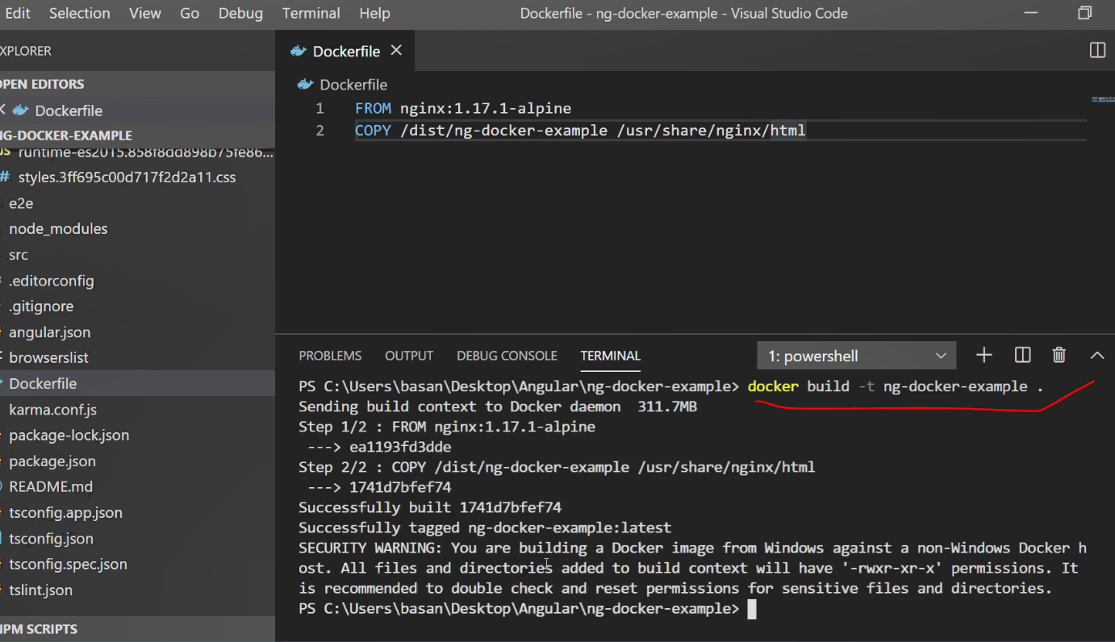

**Note:**

While building the docker image, make sure the docker terminal is up and running.

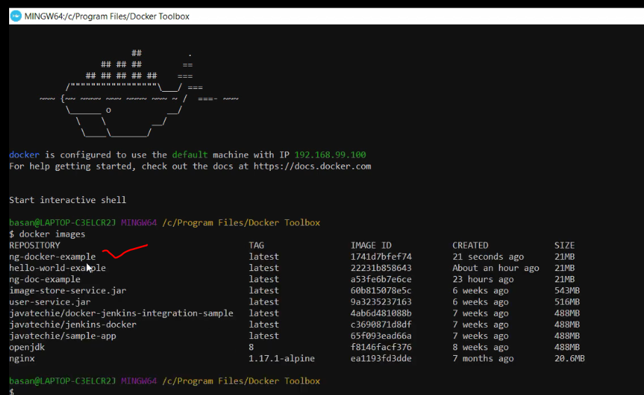

Now run the image:

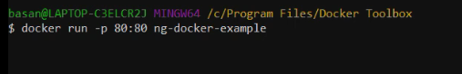

Command:

Docker run -p <any port>:<any port> <image name>

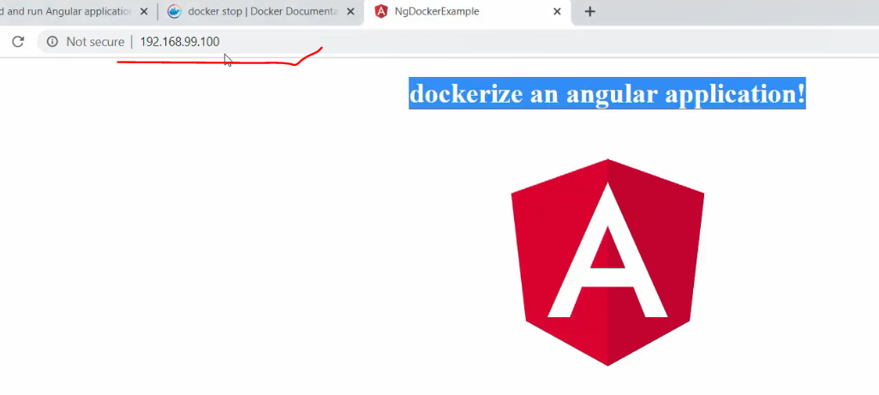

Done!